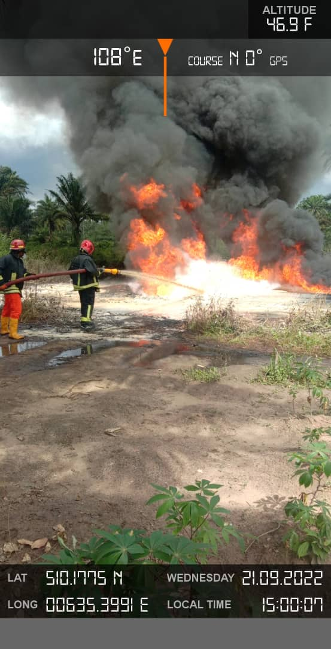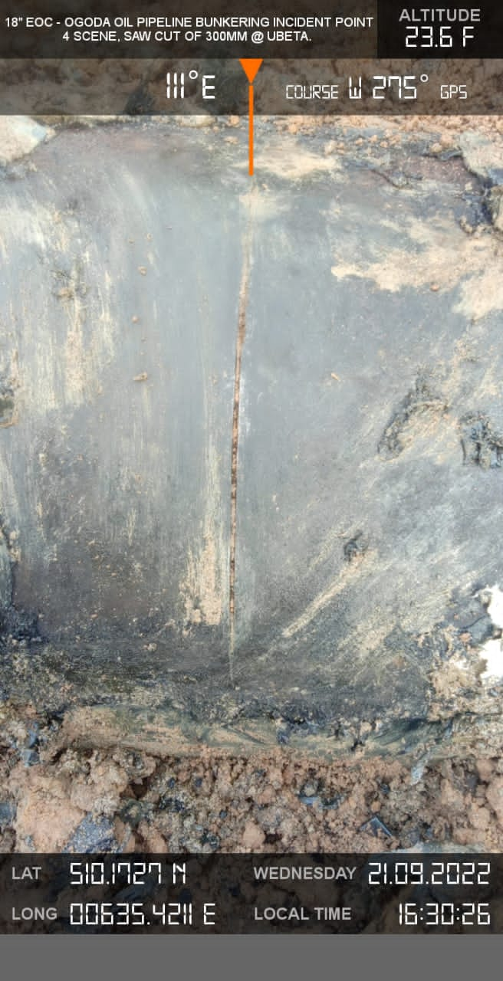
Fig 1. NAOC’s Firemen extinguishing fire Fig.2 Arrow showing Spill Point (Hacksaw cut)

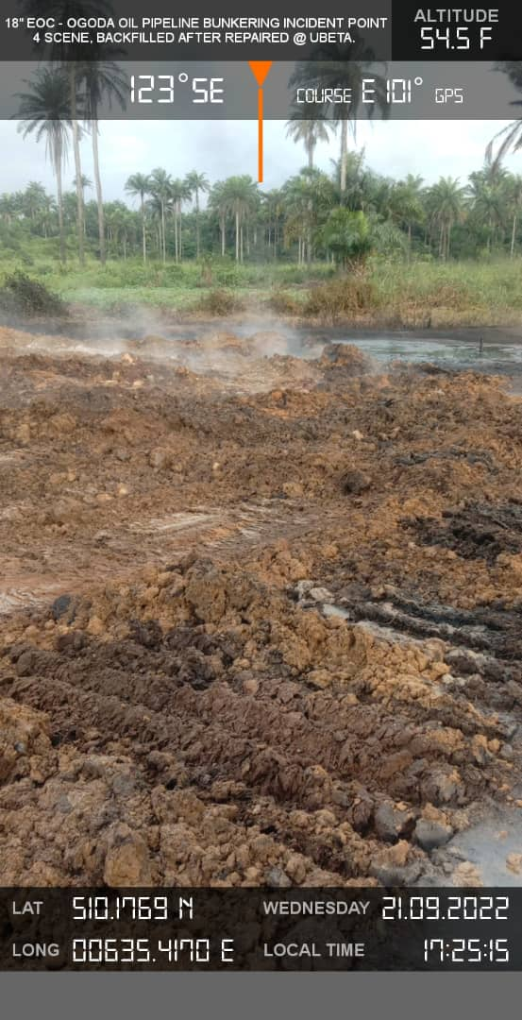
Fig.3 Area of Impact from the Spill incident

